**­­**



**REQUEST FOR PROPOSAL**

**TRUCKLOAD SHIPMENTS (Van & Flatbed)**

**This RFP package is confidential; please only share this information with members of your organization and affiliates**.

**February 2020**

**On behalf of Sims Group USA Holdings Corporation and USA Affiliates, including Sims Recycling Solutions, Inc.**

By: Stephen McCleary, CSCP

Director of Transportation – North America

Sims Metal Management

1600 Harvester Road

West Chicago, IL 60185

Telephone +1 (630) 473-6041

Mobile      +1 (630) 779-3121

Facsimile  +1 (630) 473-6191

[stephen.mccleary@simsmm.com](mailto:stephen.mccleary@simsmm.com)

[www.simsmm.com](http://www.simsmm.com)

**RFP NO: NAM 001**

**Overview**

By means of this request for proposals (RFP), Sims Group USA Holdings Corporation, which along with its United States affiliates does business as Sims Metal Management (SMM, global website: [www.simsmm.com](http://www.simsmm.com)), is seeking bids from properly qualified Transportation Service Providers (TSPs) as described below. The bid may also or just include Services for Sims Recycling Solutions, Inc. (SRS, USA website: [www.simsrecycling.com](http://www.simsrecycling.com)), also a United States affiliate of SMM.

SRS works closely with recognized industry associations to ensure that its business operations adheres to recognized industry standards; SRS has obtained and maintains the following certifications: R2:2013; ISO 14001:2015; OHSA 18001:2007; ISO 9001:2015; ISO 27001; ITAR Registered; TAPA: 2012 *(SRS, Roseville , CA Only);* NAID AAA: 2016

The intent of this RFP is to offer carriers/brokers the opportunity to bid on various lanes by SMM & SRS. All carriers/brokers are encouraged to consider during your proposal development that SMM & SRS offer year round (no peaks/valleys) moves to its preferred Transportation Service Providers. The Transportation Service Providers will honor their proposed rates in this RFP for a minimum of 1 year and will not impose any increases during that term.

Pricing is to be based on line-haul rates ONLY, without a fuel surcharge. Our Fuel Surcharge Index is attached. Lanes will be awarded on a primary and secondary transportation provider level. The most competitive Transportation Provider with the best service offering is expected to carry the majority of the lane.

**I. Introduction**

SMM/SRS are pleased to invite you to submit a formal proposal for Truckload Shipments (Van & Flatbed), which must conform to the requirements set out in this RFP.

SMM/SRS intend to select the Transportation Service Providers and award the contract to the winning bids resulting from this RFP in May 2020. Your quotation and proposal therefore should remain valid through July 2020 and pricing held valid through May 2021.

**II. General RFP & Project Objectives**

SMM & SRS are developing a comprehensive transportation program. As such, we would like to offer your company the opportunity to participate in this program. Thank you for your consideration and cooperation.

The selected Transportation Service Providers awarded the traffic lanes are expected to:

* Follow their rates and fees in this bid as shipments are tendered

Transportation Service Provider will be required to promptly report any employee injury related to the Services, no matter how small, to SMM/SRS.

**III. Critical Components of the RFP package that will be evaluated to identify the successful TSP bid.**

* Ability to adhere to our RFP format and fill out the information in its entirety;
* TSP flexible working hours if needed;
* RFP Elements and requirements for submitting your bid are described in the attached **Exhibit A (A.1 & A.2 respectively);**
* Itemized Cost of components as per bid sheet attached as **Schedules 2.1 & 2.2 (B, & C Series);**
* Bidder cannot subcontract any aspect of this bid (or the Services if selected) except with the express written consent of SMM/SRS; and
* TPSs must execute SMM’s Transportation Vendor Services Agreement (available once the TSP is selected & awarded lanes) and comply with the SMM/SRS insurance requirements, as listed in **Exhibit B.**
* TSPs must be able to service those SMM/SRS Facilities listed in **Schedule 1 (Affiliates)**.

**IV. Bidder’s basic submittal requirements:**

1. Complete proposal
2. Quotation to be itemized and provided in US$
3. Quotation Validity through performance of Services
4. Specified Payment Terms
5. Any exceptions to items requested must be clearly identified
6. Bid Sheet must be submitted on time and complete
7. Agreement to execute the SMM/SRS Transportation Vendor Services Agreement and acknowledge and comply with the SMM/SRS Insurance requirements, if selected
8. Pricing for Services (all costs)
9. Any proposed exceptions to the SMM/SRS Transportation Vendor Services Agreement

**V. All communications regarding this RFP**

For the purpose of this RFP and any resulting communication, please ensure that all queries, comments, suggestions, requests, etc., are communicated by email only to Steve McCleary ([stephen.mccleary@simsmm.com](mailto:stephen.mccleary@simsmm.com)).

**Important;** Please review the entire RFP package first and then consolidate all of your questions and requests in one email. This will eliminate multiple communications and provide a more efficient method in addressing your open items.

This procedure will assist in the streamlining of data and the dissemination of information to all concerned. Where necessary, all questions will be directed internally within SMM/SRS and communicated via Steve McCleary to all participating parties accordingly. Failure to adhere to this approach may result in disqualification of proposal.

Please submit your best proposal for the items listed on Exhibits and within the terms and conditions described below. You are required to submit your proposal on our standard forms with separate Exhibits for any additional information you wish to submit.

Due Date:

The due date for submission of proposal is **March 4, 2020 by noon.** Proposal must be e-mailed to Steve McCleary ([stephen.mccleary@simsmm.com](mailto:stephen.mccleary@simsmm.com)). Formal requests for extension may be made for consideration.

**TERM OF PROJECT:** If awarded this project, all quoted prices and conditions quoted herein shall be in full force and in effect from date of signing to termination of Agreement for Services.

**SCOPE OF PROJECT:** The expected scope of work and components are listed in the excel spreadsheet schedules (SMM TL VAN FLATBED VOL 2020) and within this document.

**RFP DOCUMENTATION INSTRUCTIONS AND NOTES**

* RFP – Electronically fill out company information, name, and phone # with Schedules 2.1 & 2.2 filled out in their entirety.
* RFP Bid Pricing Worksheet – You must indicate your unit cost for each section listed. Do not include any Federal, State, Local or Use Taxes in your pricing.
* TSPs will be responsible for complying with the SMM/SRS SHEC (safety, health, environmental & community) requirements and to comply with local, state and federal laws and governmental requirements pertaining to SHEC.
* State your warranty/guarantee for all services provided.

**Summary of Important Due Dates:**

* Notice of Interest in responding to RFP: **No later than February 21, 2020**
* Bid Submittal Date: **March 4, 2020 12:00 pm CST**
* Contract Awarded: **April 20, 2020 (subject to change)**

***[Remainder of page intentionally left blank***

**EXHIBIT A**

**A.1 RFP ELEMENTS**

**PRODUCTS**

SMM receives recyclable metal materials and ships recyclable metal commodities. SRS receives and ships electronic materials and products. In addition to these products, both businesses also ship their wastes.

SRS ships some Hazmat (<0.5%) for recycling purposes: UN Codes 2794, 2795, 2800, 2809, 3090, 3077; Classes 8 & 9.

A sample of materials shipped by SRS includes:

A sampling of materials received and/or shipped by SMM and/or SRS includes (but the below list also includes items not received or shipped by either business, e.g. “games group,” or “gums”):



**REQUIREMENTS:**

**SAFETY**

The culture of SMM & SRS is built around its core values of Safety, Integrity, Respect, Transparency, Excellence, and Social Responsibility. These core values determine who SMM & SRS are and are the foundation of everything SMM & SRS do; they set the standard for the way SMM & SRS interact with its employees, customers, communities and all stakeholders, including its vendors.

The first of those core values is Safety. SMM & SRS strive for a “ZERO-harm workplace.”

* SMM/SRS require drop trailers in docks to use wheel chocks & stands
* A number of SMM/SRS facilities have ‘Dock Locks’ and/or they may also use ‘Air Brake Locks’
* Drivers may be asked to lock their keys in a secure lock box until the trailer is completely loaded or unloaded

**SHIPPING / RECEIVING**

It is very important that all drivers conduct themselves in a positive, polite, and business manner. This might be the only interface that our customers/vendors have with SMM/SRS and your driver represents our business.

**APPOINTMENTS**

It is EXTREMELY IMPORTANT that ALL appointments are kept & met *(some SMM/SRS Customers/Vendors keep a scorecard with pick-ups & deliveries and may assess penalties and fines against SMM/SRS, which will be passed along to your company)*

* + *Once a Pick-up/Shipment is confirmed, if it is dropped by the Carrier within 12 hours or the night before, the TONU charge may be applied to the carrier by SMM/SRS.*

**SMM Inbound & Outbound Shipping**

* Appointments are not needed at most SMM locations (see Schedule 2.1b in Excel file)
  + Those locations operate on a First Come First Served basis
* Clean trailers without leakage are required
  + For the purpose of this bid:
    - 48’ or 53’ Dry Van or Refrigerated Trailers
    - Flat-beds
    - Other types of equipment are utilized (please complete section: ‘Carrier Profile Schedule 2.1a {columns BP thru BZ})
* Average weighs in pounds (lbs.):

|  |  |
| --- | --- |
| SMM | Avg Weight (lbs.) |
| Inbound Van | 30,756.90 |
| Inbound Flatbed | 25,944.85 |
| Outbound Van | 42,224.20 |
| Transfer Van | 42,955.30 |
| Transfer Flatbed | 34,382.90 |

|  |  |
| --- | --- |
|  |  |
| SRS | Avg Weight (lbs.) |
| Inbound Van | 19,375.64 |
| Outbound Van | 44,016.90 |

* Carriers are generally given 24 to 48 hours’ notice but can have same day pick-up.
* Driver signs for the load but shipments are generally shipped ‘Shipper Load and Count’ (SLC) and sealed
* Currently, shipments are usually tendered through our TMS system (Ratelinx {www.ratelinx.com})
  + Rates from this bid will apply with this on-line tendering
* Unloading and loading time is usually within 2 hours
* For safety, drivers will be asked to un-hook from the trailer or have their keys locked in a secure lock box until the trailer is completely loaded or unloaded.
* Please refer to the Excel file *(SRS_SMM_TRUCKLOAD SCHEDULES.xls* worksheet Schedule 2.1B) for Sims Metal Management’s yard locations and hours of operation.
* Car Body Hauling **(see pictures below)**
  + Spread Axle Trailers
  + Requires 3 chains per stack of cars
    - Stacks must be tarped or netted (per federal and/or State requirements)
  + “Wet” Cars – Rims/tires still on the vehicle
    - Vehicle NOT flattened
    - Fluids still in the vehicle
  + Crushed Cars
    - Rims/tires may or may not be on the vehicle
    - Fluids drained
    - Vehicles Flattened

**SRS Inbound Shipping**

* Inbound Freight consists mostly of palletized electronic waste from schools, universities, office buildings, warehouses, production facilities, hospitals, and medical facilities.
* Pick-up appointments at the customers locations are required
  + It is EXTREMELY IMPORTANT that ALL appointments are kept & met *(SRS customers keep a score card with pick-ups & deliveries and may assess penalties and fines against SRS which will be passed along to you)*
  + *Once a Pick-up/Shipment is confirmed, if it is dropped by the carrier within 12 hours or the night before, the TONU charge may be applied to the carrier by Sims.*
* Carriers are generally given 24 to 48 days’ notice but can have same day pick-up
* Deliveries are mostly sealed (SLC) and require a Sims employee to verify and break the seal
* Some Pick-ups may require lift gate service.
* Tandem wheels on the trailer may require adjustment to be unloaded at the dock
* Average inbound trailer weighs 19,375.6 pounds on 26 pallets
* Unloading time at a SRS facility is 20 minutes to 2 hours depending on the type of load (palletized or bed-load).
* For safety, drivers will be asked to un-hook from the trailer or have their keys locked in a secure lock box until the trailer is completely loaded or unloaded.
* Currently, shipments are usually tendered through our TMS system (Ratelinx {www.ratelinx.com})
* Notify SRS dispatcher immediately of any pick-up or delivery discrepancy.

**SRS outbound Shipping**

* Distribution is to other SRS facilities or downstream processing plants.
* Delivery appointments at the some locations are required
  + It is EXTREMELY IMPORTANT that ALL appointments are kept & met *(SRS customers keep a score card with pick-ups & deliveries and may assess penalties and fines against SRS which will be passed along to you)*
  + *Once a Pick-up/Shipment is confirmed, if it is dropped by the carrier within 12 hours or the night before, the TONU charge may be applied to the carrier by Sims.*
* Clean trailers without leakage are required
  + 48’ or 53’ Dry Van or Refrigerated Trailers
* Loads are palletized, stretch wrapped either on 40x48 GMA pallets or in gaylords or super sacks.
  + Pallet exchange is not required.
* Tandem wheels on the trailer may require adjustment to be unloaded at the dock
* Average outbound van trailer weighs 44,016.9 Pounds on 33 pallets
* Carriers are generally given 24 to 48 hours’ notice but can have same day pick-up
* Loading time is generally 20 minutes to 1 hour.
* Most of the deliveries are to the customers Warehouses, Distribution Centers (DC) or processing plants
* Driver signs for load but Shipments are generally shipped ‘Shippers Load and Count’ (SLC) and sealed
* For safety, drivers will be asked to un-hook from the trailer or have their keys locked in a secure lock box until the trailer is completely loaded or unloaded.
* Currently, shipments are usually tendered through our TMS system (Ratelinx {www.ratelinx.com})
  + Rates from this bid will apply with this on-line tendering

***EXAMPLES of CARS STACKED on a FLATBED (DEPICTION IS NOT REPRESENTATIVE OF COMPLIANCE REQUIREMENTS)***

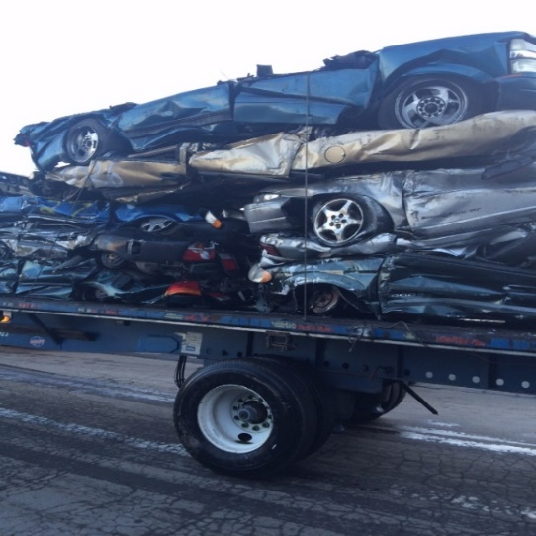



***PICS OF LOADS (VAN TRAILERS)***

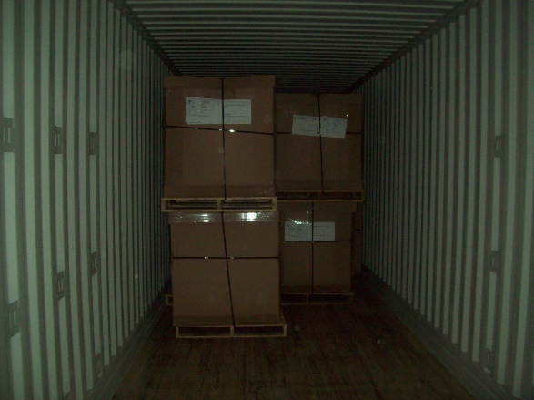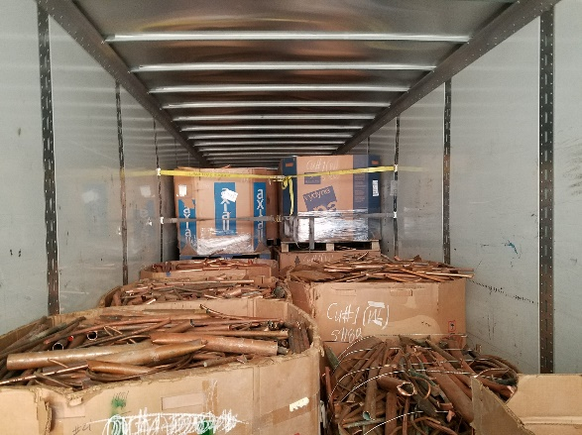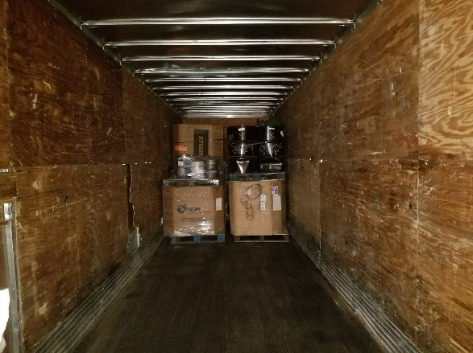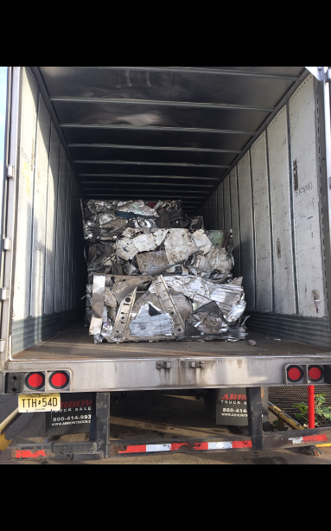

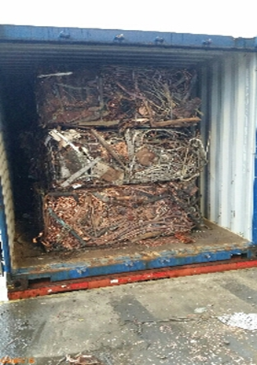

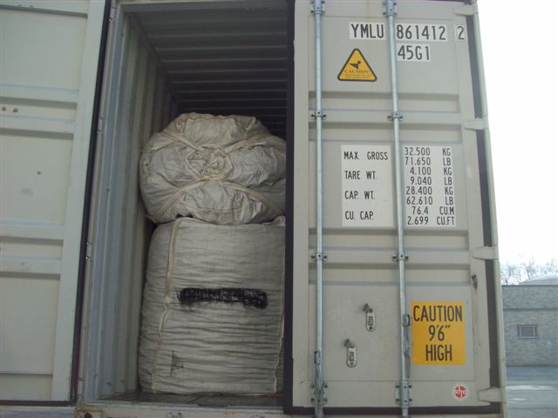

# **.**

**SMM –DAILY TRANSFER LOADS**

Schedule 2.2D – DAILY SHIPMENTS in the Excel Spreadsheet has a number of daily flatbed loads available (M-F). The material is tin bales and require netting which is available at the pick-up locations. With these loads, we are looking for Line-haul rates below market where one of your carriers would be covering the lane deadhead miles. You may find these shipments on our TMS ([www.ratelinx.com](http://www.ratelinx.com)).

***PICS OF TIN BALE LOADS w/NETTING***

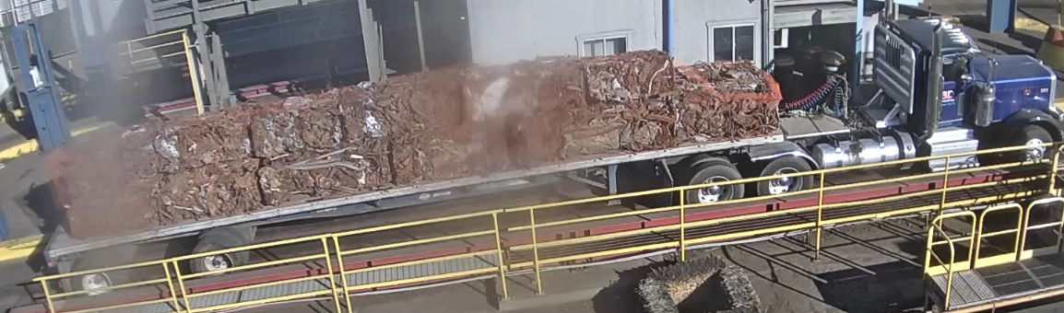

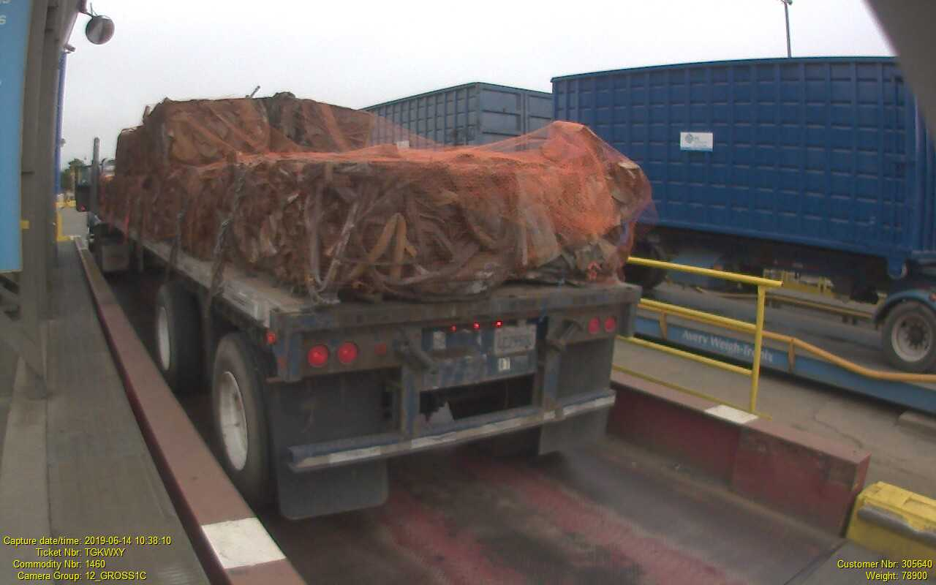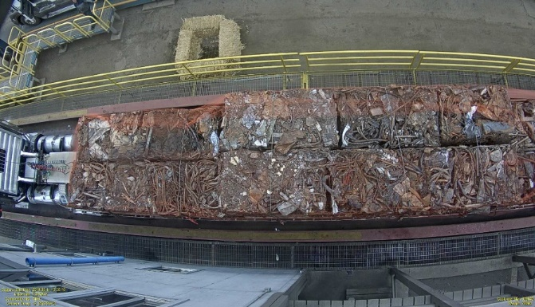

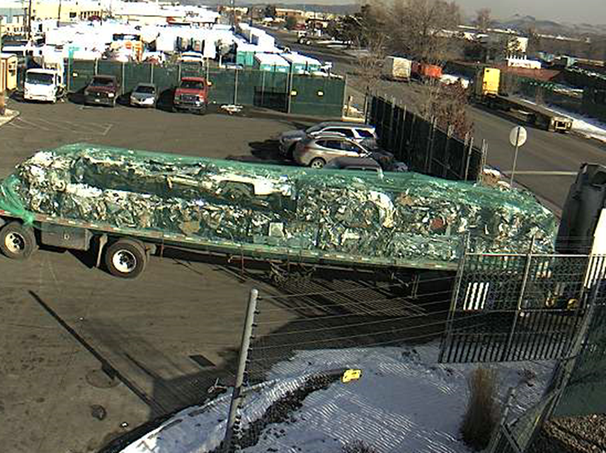

# **PAYMENT**

SMM and SRS currently pay their invoices through a third party audit provider, Ratelinx ([www.ratelinx.com](http://www.ratelinx.com)). RateLinx (or a comparable service provider) will act as a pay agent on behalf of both companies (SMM & SRS) and will send funding to the carrier for valid freight charges. While RateLinx currently will act as pay agent, SMM & SRS will be ultimately responsible for payment of legitimate freight charges.

The method for submitting your freight invoices through RateLinx (service provider and method are subject to change):

*RateLinx Web Portal*

* 1. Using the portal, you do not have to create an invoice; the information entered into the portal will generate an invoice for you. Entry through the portal also assists in you receiving your payment faster because the portal will prompt you if you enter a MMO or Ticket number that does not match our records.
* Payment is made within terms (preferred with a discount) or Net 30 days from date of received invoice
* ALL invoices must be submitted in a timely and accurate manner
  + All Charges need to be submitted with the original invoice
    - This is extremely important so that we may correctly close the business cycle with our customers
* For Deliveries and Pick-ups, we require Proof of Delivery (POD) or Interchange Receipt (TIR) attached (electronically) to the freight invoice.
  + Reference the Bill of Lading number along with the Material Management Order number (MMO) or Ticket # and the Container #(s)
  + Each charge with a shipment needs to be a separate line item
    - Fuel Surcharge NEEDS to be separated from the Line-Haul Rate
    - All the charges for each shipment must be on the invoice
      * Multiple invoices cause delay in payments and are unacceptable

**OTHER REQUIREMENTS**

* Sign an MSA Agreement (the Transportation Vendor Services Agreement) covering among other things the following:
  + Expectations/ Service Requirements/ Scope of Work
  + Rates & Accessorial Fees (Submitted from the RFP)
  + Responsibility
  + Liability & Risk Allocation; Indemnification
  + Insurance
    - Requiring Endorsements for Additional Insured along with Waivers of Subrogation
  + Safety & Compliance Requirements
  + Invoicing & Payment
  + Handling of Material
  + Confidentiality
  + Brokers/Carriers Responsibility

**PERFORMANCE REPORTS**

SMM & SRS will require the selected carrier(s) to provide a performance report on a weekly basis, on the previous week’s shipments. This report would include:

Previous week's shipments including ALL exceptions to standards along with an explanation of the exception(s).

* Number of inbound & outbound shipments
* Weight of each shipment
* Average transit time
* Percentage (%) of shipments completed on-time
* Number of loads tendered
  + Percentage (%) of load turned down
    - Reason
* Current DOT Safety Rating
* Current CSA Scores

Quarterly Business Review (QBR) with SMM/SRS representatives either in person or via conference call to be arranged by SMM/SRS. Topics to include:

* Quarterly & YTD (Year to Date) activity provided in advance of meeting
* Current DOT Safety Rating and SMS Scores will be reviewed Quarterly
* CTM (Collaborative Transportation Management) - Open discussion to keep cost down and improve service levels.

This report should include **ALL** the exception(s) and why there were exceptions to the standard. SMM and/or SRS will also require immediate notification of any discrepancy discovered after shipment pick-up. The reports should be available to be sent electronically at the beginning of the following month on a specified day to an email address that will be determined at a later date. In addition, the management staff at SMM and/or SRS would also like to have quarterly meetings to review these reports and discuss ways in which they may help you achieve a high level of service while keeping the costs down.

**EXHIBIT A**

**A.2 SUBMITTING YOUR BID**

Contained in this RFP package is a spreadsheet (**Schedule 2.1a**) entitled “***Carrier Profile and Information***.” This Schedule requests general information about your company, as well as your daily equipment availability, and **MUST** be completed and included with your bid package.

**SUBMITTING YOUR BID**

***Truckload***

Also enclosed is a workbook with spreadsheets that provide point-to-point freight movements (Schedule 2.2: B series). This Schedule requests per mile and per vehicle pricing for each move. For Schedule 2.2 ‘(a)’ series (Over-the-Road rates): enter your rate in the column entitled ‘*Line-haul Bid Price per Vehicle’* by designated city. Your pricing must be on both a ‘cost per mile’ (column L) and ‘per truckload’ (column M) in the designated cells. In addition, in column G the miles have been calculated for each traffic lane and in column M enter in the minimum charge (in $) if greater than the mileage line-haul rate.

**BREAKDOWN of BID RATE EXHIBITS**

Schedule 2.2 B series (1&2) - Specific Line-Haul Rates per Truckload

*These Schedules are for specific over-the-road truckload moves*

* **Origin City** (column A) – the City in which the load will be picked up
* **Origin St./Prov.** (column B) – the State/Province in which the load will be picked up
* **Orig. Zip/Postal** (column C) – the Zip/Postal code in which the load will be picked up
* **Dest. City** (column D) – the City to which the load will be delivered
* **Dest. St./Prov** (column E) – the State/Province to which the load will be delivered
* **Dest. Zip/Postal** (column F) – the Zip/Postal code to which the load will be delivered on this specific lane
* **Miles** (column G) – the distance in miles from origin to destination based on PC Miler v29
* **Monthly Loads** (column H) – the number of monthly loads available on this specific lane as determined from data for Jul 2019 to Dec 2019.
* **Carrier Name** (column I) – Enter here your Carrier business’ legal name
* **Type of Equip** (column J) – Enter here the type of equipment being used to pull the load
* **Type of Shipment** (column K) – specific requirements with the shipment, if any
* **Prop L/H Chg. per Mile** (column L) – Enter here the rate per mile
* **Prop L/H Chg. per T/L** (column M) – Enter here the cost per truckload for this lane - either the minimum charge or the rate, whichever is greater
* **Grade Category** (column O) – the type of material being shipped
* **Currency (US$ or CDN$)** (column P) – Enter here the currency that the rate is based on (US$ or CDN$)
* **Region** (column Q) – the Region that is responsible for the shipment
* **Remarks** (column S) – Any additional Information may be indicated

***Intermodal***

For Schedule 2.2 C series (Inter-modal rates): enter your rate in the column entitled ‘D to D T/L Length’ for each size trailer or container that pertains to the designated city. Your pricing must be door-to-door rate per trailer length (columns I through R) in the designated cells. In addition, enter Transit time in days (column T) and the number of trailers available weekly in columns M & S.

Schedule 2.2 B & C ‘(b)’ series - Specific Rates per Trailer either TOFC or COFC

*This Schedule is for specific Inter-modal trailer moves (door to door)*

* **Origin City** (column A) – the City in which the load will be picked up
* **Origin St./Prov** (column B) – the State/Province in which the load will be picked up
* **Orig. Zip/Postal** (column C) – the Zip/Postal code in which the load will be picked up
* **Dest. City** (column D) – the City to which the load will be delivered
* **Dest. St./Prov** (column E) – the State/Province to which the load will be delivered
* **Dest. Zip/Postal** (column F) – the Zip/Postal code to which the load will be delivered
* **Monthly Loads** (column G) – the number of monthly loads available on this specific lane as determined from data for Jul 2019 to Dec 2019.
* **Carrier Name** (column H) – Enter here your Carrier business’ legal name
* **D to D Trailer/Container Size** (columns I-R) – Enter here the rate to move the trailer by size door to door
* **Wkly Equip Avail.** (column M & S) – Enter here the quantity of Trailers/Containers available on this specific lane
* **D to D Transit Time** (column T) – Enter here in days the time it will take to move the load from the generator’s dock door to the mill’s dock door.
* **Currency US$ or CDN$** (column U) – Enter here the currency that the rate is based on (US$ or CDN$)
* **Type of Shipment** (column V) – any specific requirements with the shipment
* **Grade Category** (column X) – the type of material being shipped
* **Region** (column Y) – the Region that is responsible for the shipment
* **Remarks** (column AA) – Any additional Information may be indicated

Schedule 2.2D - Specific Line-Haul Rates per Truckload

*These Schedules are for specific over-the-road truckload moves*

* **Origin City** (column A) – the City in which the load will be picked up
* **Origin St./Prov.** (column B) – the State/Province in which the load will be picked up
* **Orig. Zip/Postal** (column C) – the Zip/Postal code in which the load will be picked up
* **Dest. City** (column D) – the City to which the load will be delivered
* **Dest. St./Prov** (column E) – the State/Province to which the load will be delivered
* **Dest. Zip/Postal** (column F) – the Zip/Postal code to which the load will be delivered on this specific lane
* **Miles** (column G) – the distance in miles from origin to destination based on PC Miler v29
* **Daily Loads Available** (column H) – the number of daily loads available on this specific lane as determined from data for Jul 2019 to Dec 2019.
* **Carrier Name** (column I) – Enter here your Carrier business’ legal name
* **Type of Equip** (column J) – Enter here the type of equipment being used to pull the load
* **Type of Shipment** (column K) – specific requirements with the shipment, if any
* **Prop L/H Chg. per Mile** (column L) – Enter here the rate per mile
* **Prop L/H Chg. per T/L** (column M) – Enter here the cost per truckload for this lane (this would be a shipment as a filler for deadhead miles)
* **Grade Category** (column O) – the type of material being shipped
* **Currency (US$ or CDN$)** (column P) – Enter here the currency that the rate is based on (US$ or CDN$)
* **Region** (column Q) – the Region that is responsible for the shipment
* **Remarks** (column S) – Any additional Information may be indicated

**Please note equipment requirements. Provide rates only on those moves where you have the specified type of equipment.** For the purpose of this bid, rates on moves within the U.S. and between Canada and the U.S for U.S. destinations must be stated in U.S. dollars

Mileage will be determined by the **PC Miler program** version 29. In addition, the miles (column G) in the Schedules 2.2B-(1&2) series were determined with this program. If you are awarded the business on these lanes, it is expected that this is the mileage base that will be used for billing.

All proposed pricing **must be without** fuel surcharge. We are enclosing a proposed fuel surcharge schedule (**Schedule 2.3**). All carriers should be party to this schedule.

You must complete the “*Carrier Profile and Information*” - **Schedule 2.1A**. This Schedule **must accompany** all bid proposals. Provide your bid pricing with the use of the attached excel spreadsheet, make a copy for yourself, and email it to the address listed below, in the *‘Subject Line’* please put **TRUCKLOAD PROPOSAL FEB 2020**.

The term of your proposal relating to rates should be effective for a minimum of one year and possibly multiple years. Prior to implementation, potential participants will be asked to meet with us at the respective facility (s). The meeting date and place will be determined after the bid responses have been processed. Each carrier will be given ample opportunity to discuss operational matters.

Any additional rules not addressed in this **Exhibit A** should be referred to in your rules tariff and a copy of such tariff must be provided with your bid.

**SUBMISSION REQUIREMENTS:**

* **Equipment:** Provide rates only on those moves where you have the specific type of equipment.
* **Currency:** Pricing for all moves within the U.S. and between the US and Canada must be stated in U.S. dollars. This must be indicated on the various worksheets under the column entitled *‘Currency’*.
* **Prices for Canadian movements** are to be exclusive of HST. HST is to be shown as a separate item if applicable.
* **Cross Border:** Carriers must follow PIP (Partners in Protection) and C-TPAT (Customs Trade Partnership Against Terrorism) guidelines. For quicker border crossings, preference is given to FAST TRAC (Free and Secure Trade) participants. Multi-pallet shipments must be kept together to avoid any delays.
* **Mileage** to be determined by PC Miler Program Version 29. Pricing & invoicing must be based on PC Miler. NOTE: Miles in Schedules 2.2B & C in Column G are based on PC Miler.
* **Fuel Surcharge:** Pricing to be **exclusive of fuel surcharge.** SMM fuel surcharge schedule (Schedule 2.3) is included. Carriers must **be party** to this schedule.
* **“*Carrier Profile and Information*”** (Schedule 2.1A): Must be **completed and accompany** all bid proposals.
* **Proposal Term:** Effective for a **minimum of one year.**
* **Proposal Final Submission**: Provide your bid pricing with the use of the excel spreadsheet on-line (http://simsrecycling.com/logistics-freight-rfp), download it, make a copy for yourself, then email it to the address listed below, in the *‘Subject Line’* please put TRUCKLOAD FEB 2020. *If you prefer we may provide you with an electronic version of this bid for you to complete and email back to us.*
* **Implementation:** Selected Carriers will be asked to meet with SMM at the respective facilities. The meeting date and place will be determined after the bid responses have been processed. Each Carrier will be given ample opportunity to discuss operational matters.
* **Additional Rules:** Any items not addressed in this Exhibit A should be referred to in your rules tariff and a copy of such tariff must be provided with your bid.
* **Brokers:** Provide carrier selection criteria as well as a schedule on the monitoring of selected carriers. Please bid only those lanes that you have both interest and equipment availability to serve on a regular basis. Occasional equipment availability is **NOT** acceptable.
* **Pricing Guidelines:**
* Intermediary Stop-Off Charge - $50 per stop
* Loading and Unloading free time (per stop) – 3 hours
* Trailer Order Not Used (TONU) - $100
* Driver Detention - $50/hr. *– increments of quarter hour*
* Driver Assist - $40
* Minimum Truckload Rate
  + Less than (<) 250 miles - $100
  + Equal to or greater than (>) 250 mile - $250
* O/W Permits – Pass through with a receipt
* Lift Gate service - $25
* Pallet Jack - $20
* Drop Trailer – No Charge
* Layover - $150
* Full Tarp - $50

The Bidder’s proposal and service has to fully comply with the requested specifications as well as all the terms and conditions noted in this RFP. The Bidder should meet or exceed the specifications set out in this RFP document. Prices offered must be met and must be held until services and goods are delivered and or installed, if applicable. **No escalator clauses will be accepted.**

The Bidder’s proposal and service has to fully comply with the requested specifications as well as all the terms and conditions noted in this RFP. The Bidder should meet or exceed the specifications set out in this RFP document. Prices offered must be met and must be held until services and goods are delivered and or installed, if applicable. No escalator clauses will be accepted unless mutually agreed upon.

**PREFFERED CARRIER**

Awarded transportation providers may (or in the case of SRS (an R2 Certified Recycler) will) be asked to complete a questionnaire from our Safety Health Environment and Community (SHEC) team to verify regulatory authorizations and compliance.  Sample questions may include:

1. *Does your company have an emergency response plan that addresses potential accidents or other incidents during transport?*
2. *Has the company received any fines, regulatory orders, or experienced any environmental incidents such as spills in the past 3 years?*
3. *Is there a controlled substance abuse program, e.g. DOT program for truck drivers?* 
   1. *When was the last time a driver went for a random drug/alcohol testing?*

A review of the transportation providers will also be conducted with the U.S. DOT on-line database*.*

Please bid only those lanes that you have both interest in and equipment availability for to serve on a regular basis. Occasional equipment availability will not be acceptable. **It is not required that you participate from all locations on all lanes – only those locations and traffic lanes where you can provide equipment and service on a regular basis.**

If you are interested in any of this business, please respond directly to:

**Stephen McCleary, CSCP**

**Director of Transportation – North America**

**Sims Metal Management**

**1600 Harvester Road**

**West Chicago, IL 60185**

**Telephone +1 (630) 473-6041**

**Mobile +1 (630) 779-3121**

**Facsimile +1 (630) 473-6191**

[stephen.mccleary@simsmm.com](mailto:stephen.mccleary@simsmm.com)

Should you have any questions, please call Steve McCleary at the above number. We ask that you not contact the facilities directly at this time.

Please review the information carefully and complete your response (including with respect to the Exhibits, completion of the Schedules) with your best proposal. We require your bid package, in hand, by:

**4 MARCH 2020**

Thank you for your consideration and effort. We look forward to hearing from you.

Sincerely,

**Stephen R McCleary, CSCP**

Director of Transportation – North America

**SCHEDULES TO EXHIBIT A**

Attached are the following **confidential** exhibits that are formatted in Excel 2003 for Windows. The exhibits provide basic information about SMM/SRS and detail the annual outbound and inbound truckload activity that is the subject of these bids.

* Schedule 1- Affiliates
* Schedule 2.1A – Carrier Profile and Information
* Schedule 2.1B – SMM & SRS Locations and Hours
* Schedule 2.2 – Lane Analysis: Inbound & Outbound
  + Schedule 2.2B-1 –SMM & SRS Annual Inbound Specific Point-to-Point Loads: Domestic US: (a) Over-the-Road – Van & (b) Inter-modal
  + Schedule 2.2B-3 – SMM Annual Inbound Specific Point-to-Point Loads - Domestic US:

(a) Over-the-Road – Flatbed

* + Schedule 2.2C-1 – SRS & SMM Annual Outbound Specific Point-to-Point Loads - Domestic US: (a) Over-the-Road – Van & (b) Inter-modal
  + Schedule 2.2C-3 – SMM Annual Inbound Specific Point-to-Point Loads - Domestic US:

(a) Over-the-Road - Flatbed

* Schedule 2.3 – Uniform Fuel Surcharge Index

**Exhibit B**

**INSURANCE REQUIREMENTS**

Both SMM & SRS use a service called MyCOI ([www.mycoi.com](http://www.mycoi.com) ) to maintain and track all the insurance certificates with our vendors. If selected as one of our transportation providers you will be required to register with them and have a current copy of your COI on file. There is a cost for registration.

The minimum insurance coverage requirements are:

* Greater of Bidder’s normal or customary or Statutory Workers’ Compensation Insurance which shall fully comply with the statutory requirements of all applicable state and federal laws;
* Employers Liability at a level greater of Bidder’s normal or customary or $1 million per occurrence for injury or death, including without limitation coverage for occupational disease;
* For employees of Bidder who are Owners of the Bidder, evidence of medical insurance;
* Commercial General Liability (using occurrence form) in an amount Greater of Bidder’s normal or customary or $1 million per occurrence and $2 million aggregate, including Blanket Contractual Liability, Products and Completed Operations Liability, Broad Form Property Damage endorsement, and Personal Injury;
* If using SMM/SRS Equipment, Property Damage at the full replacement value of SMM/SRS Equipment for physical loss or damage, naming SMM/SRS as loss payee.
* Auto Liability in an amount Greater of Bidder’s normal or customary or $1 million per occurrence for Bodily Injury and Property Damage, on all Vehicles Owned, Hired, or Non-Owned, declaring “Any Auto” or the equivalent, using ISO Policy Form CA 00 0103 or later edition.
* Excess/Umbrella Liability (occurrence) in an amount greater of Bidder’s normal or customary or $2 million per occurrence and aggregate, including coverage for all occurrences provided by all underlying coverages specified above (excluding Workers Compensation).
* For transportation of Goods consisting of SMM/SRS Equipment or Vanloads or Gaylords or Containers of Goods (e.g. via Drayage, Van, Intermodal or flatbed), Cargo Liability Insurance in an amount greater of Bidder’s normal or customary or $100,000 for loss of or damage to Goods carried on any one motor vehicle and $100,000 for aggregate of losses or damages of or to property occurring at any one time and place. If additional amount of Cargo Liability Insurance is required by SMM/SRS, the parties will arrange for such applicable additional amounts for the direct incremental cost of such additional coverage to the Bidder.
* Carrier shall be responsible for loss to Sims property and its customer property, directly or indirectly, and shall maintain fidelity bond or crime coverage for the dishonest acts of its employees.
* SMM/SRS will need additional insured endorsements for General Liability & Automobile Liability.
* Additional insurance requirements are provided in an Exhibit to the applicable SMM/SRS Vendor Services Agreement that each successful transportation services provider will need to sign.

**EXHIBIT C**

**RFP TERMS AND CONDITIONS**

1. Bidders shall bear all costs associated with the preparation and submission of bids. SMM/SRS will not under any circumstances be responsible or liable for such costs, regardless of the conduct or outcome of the RFP process.
2. No Bidder shall have any claim for any compensation of any kind whatsoever as a result of participating in this RFP. By submitting a bid, each bidder shall be deemed to have agreed that it has no such claim.

Without restricting the generality of the foregoing, each Bidder, by submitting a bid, agrees that in the event any or all bids are rejected or disqualified for any reason, or the project or this RFP process is modified, suspended or cancelled for any reason (including modification of the scope of the project or modification of this RFP):

* + 1. Bidders waive any and all claims whatsoever, including claims for loss of profits or loss of opportunity;
    2. Neither SMM nor SRS, nor any of their affiliates, nor any of their employees, advisors or representatives (each a SMM Party) will be liable, under any circumstances, for any claim or to reimburse or compensate any bidder in any manner whatsoever including but not limited to costs of preparation of a bid, loss of anticipated profits, loss of opportunity or for any other matters; and
    3. Neither SMM nor SRS is bound to explain its decision to unsuccessful Bidders.

1. No Bidder shall subcontract part or the entire submission or implementation of any requirements of this RFP without written approval from SMM or SRS, as applicable.
2. SMM and SRS are entitled to incorporate part or the entire RFP response in an agreement with the successful Bidder as appropriate.
   * 1. This RFP does not constitute an offer to enter into any contract with any party, including any Bidder, nor does it represent a contract or agreement between any party, including any Bidder, and SMM or SRS.
     2. This RFP does not constitute an offer to buy, lease, or hire goods, property, or services.
     3. Neither SMM nor SRS is bound to award a contract to any party, including any Bidder.
     4. Neither SMM nor SRS is bound to evaluate or accept any bid, and each reserves the right, in its sole discretion, to:
        1. not consider any or all bids;
        2. clarify, modify or amend the terms or contents of this RFP at any time;
        3. waive, or request that any Bidder clarify or rectify, any obscurity, deficiency, defect, omission, non-compliance or other failure to comply with the terms and conditions of this RFP found in any bid that, in the sole discretion of SMM or SRS (as applicable), is deemed not to be material, and proceed to evaluate that bid, as submitted or as so clarified or rectified; or
        4. determine the following, without regard to any industry custom or practice in the exercise of its discretion:
           1. materiality of any obscurity, deficiency, defect, omission, non-compliance or other failure to comply with the terms and conditions of the RFP;
           2. whether or not to:

disqualify any bid;

waive any obscurity, deficiency, defect, omission, non-compliance or other failure to comply; and/or

require or invite clarification and/or rectification; and/or

* + - * 1. the adequacy and acceptability of any clarification or rectification submitted by a Bidder;
      1. amend, postpone or cancel any part or phase of this RFP process at any time and for any reasons, including extending the time and date of the closing of the RFP;
      2. cancel this RFP process in its entirety at any time and for any reason, and in its sole discretion and, if and as it sees fit, re-issue an RFP or request for qualifications, quotations, proposals, bids, tenders or expressions of interest in relation to the same or a similar project at any time and from time to time;
      3. accept any bid in whole or in part, and with or without negotiations, that, in SMM’s or SRS’s (as applicable) sole discretion, offers the best overall value to SMM/SRS, and in particular reserves the right in its sole discretion to accept a bid other than:

the bid with the lowest financial cost to SMM or SRS; or

the bid with the highest rating at the conclusion of evaluation by SMM or SRS;

* + - 1. conduct post-closing negotiations with one or more bidders as it deems appropriate or necessary in its sole discretion, without under any circumstances disclosing information contained in any bid to any other Bidder;
      2. amend, postpone or cancel the project that is the subject matter of this RFP, including alteration of any dates or scheduling in relation to the project that is the subject matter of this RFP; and/or
      3. Reject any or all bids.

1. SRS & SMM are under no obligation to:
   1. interpret or respond to questions from interested parties or bidders;
   2. return any bids;
   3. accept any bids;
   4. accept the bid with the lowest financial cost to SMM or SRS;
   5. accept the bid with the highest rating at the conclusion of evaluation by SMM or SRS; or
   6. enter into a contract with any party, including any Bidder, in respect of the project that is the subject matter of this RFP.
2. SMM & SRS reserve the right to modify the proposed schedule of events as necessary.
3. Attempts to contact any other person or departments directly (other than the sender) regarding this RFP may result in disqualification.